**How to use the Mechanical Turk Processor (v 1) on a Mac**

**If you haven’t used it before:**

First there are a few things you need to install on your computer that this program depends on. If you haven’t run the program on your machine yet, follow the below instructions:

1. Find the application called “Terminal” on your computer, it should be in the following location, but if it isn’t you should be able to find it via the search icon (🔍) on the right side of the toolbar.
2. Install homebrew:
   1. Copy and paste the following text into the terminal window, after the $:

ruby -e "$(curl -fsSL https://raw.githubusercontent.com/Homebrew/install/master/install)"

* 1. Press “Enter”

1. Install python 3:
   1. After the install is completed and you have the “$” back, copy and paste the following after the $ and press enter:

brew install python3

1. Install numpy:
   1. Again after you have “$” back, copy and paste the following and hit enter after the $:

pip3 install numpy

Once you have the $ back you are ready to run the program

**Running the Mechanical Turk Processor**

**(Start here if you already have everything from part 1 installed)**

1. Navigate to the folder containing the data you want to process:
   1. In the terminal window, type

cd

and press “Enter”

* 1. Type cd again, followed by a space then the file path to the folder with the data you want to use. If you don’t know it:
     1. Navigate to the the folder as you normally would, (using the finder and double clicking on folders)
     2. then right-click on the folder containing the data and click “Get Info.”
     3. In the window that pops up, copy the information after “Where.” The window should look like this:

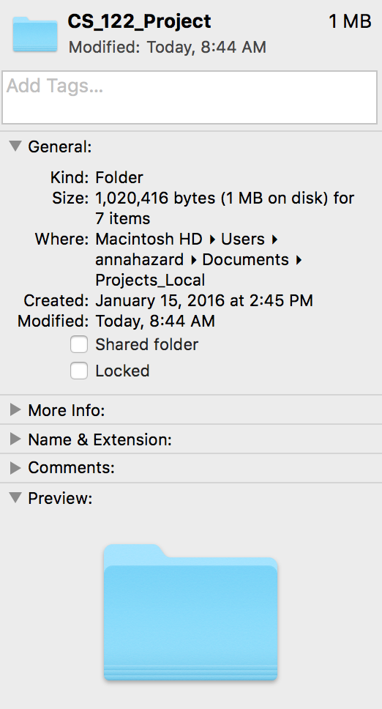

* + 1. Paste the copied information into the terminal, after “cd” and a space. When pasted, the file path should look something like this:

cd /Users/annahazard/Documents/Projects_Local

* 1. Press “Enter”

1. Run the program on each file you want to process. This will not change the files you are processing, it will just create new files.
   1. In the terminal window, type the following:

python3 mechanical_turk_processor.py "sample.csv" "AB" "AC" "AE" "BC" "new_folder/test.csv" “AD”

where “sample.csv” should be replaced by the file you wish to process

and “AB” should be replaced with the alphabetical code in excel for the column that contains the first names of candidates

and “AC” should be replaced with the alphabetical code in excel for the column that contains the first names of candidates

and “AE” should be replaced with the alphabetical code in excel for the first column containing the urls to be transferred to the new file, and “BC” the last column containing these urls

and “test.csv” should be replaced by the desired new file name and path. If no path is provided, the files will be created in the same folder. **Every time the program is run, a new file name should be provided or previously created files will be overwritten.** Currently this program can only take one file at a time and produces one file at a time. (Each time it is run)

Lastly, “AD” should be the column of the candidates unique identifier: something unique to each candidate. Last names should not be used if there is a possibility that candidates share a last name. In testing, the column containing the starting url for each candidate was used.